Scott Chamberlain
CSD325-T301
Module 2.2 Assignment
3/24/2026

Screenshot 1
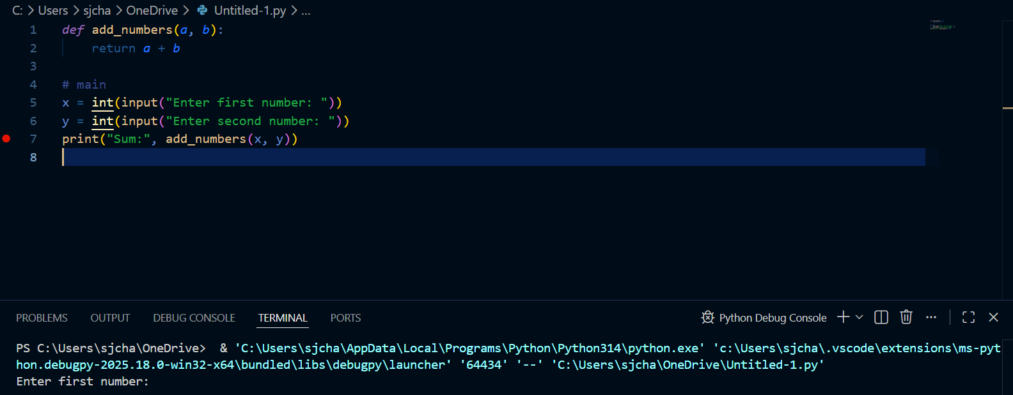

Screenshot 2:
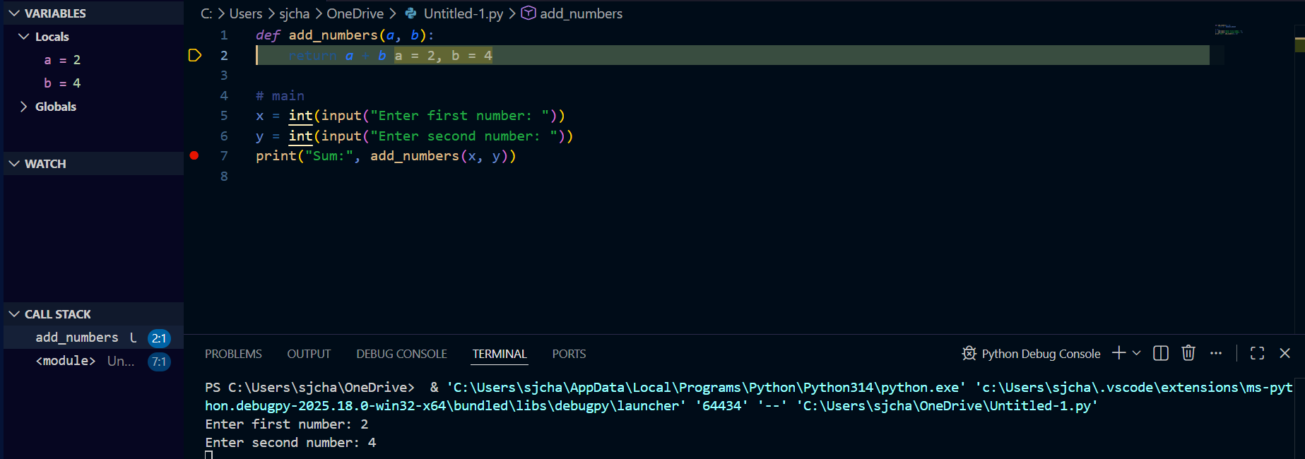

Screenshots 3:

